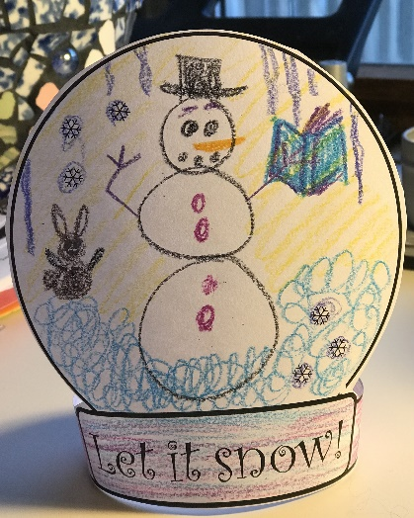

**Make your own Snow Globe**

Color a snow scene in the globe

Cut around the edges

Attach the long ends together

❄

❄

❄

Let it snow!

❄

❄

❄